Top 20 Project Sponsor Types
By Chintan Shah
As part of PMI Australia Conference, I attended Masterclass Strategies for Project Sponsorship with The Lazy PM Peter Taylor.
During the day we completed several exercises that generated several engaging and interesting discussions. Each discussion described Sponsors in different light. I took notes of several different types of Sponsors we see in the real world. Personally, I feel that Sponsors can make or break your Projects. Depending on the interest and influence your Sponsor brings, it can be a smooth ride as a Project Manager or a battle you need to fight on your own. Luckily, I have found myself working with engaged and influential Sponsors and learned strategies to manage them better at the Masterclass.
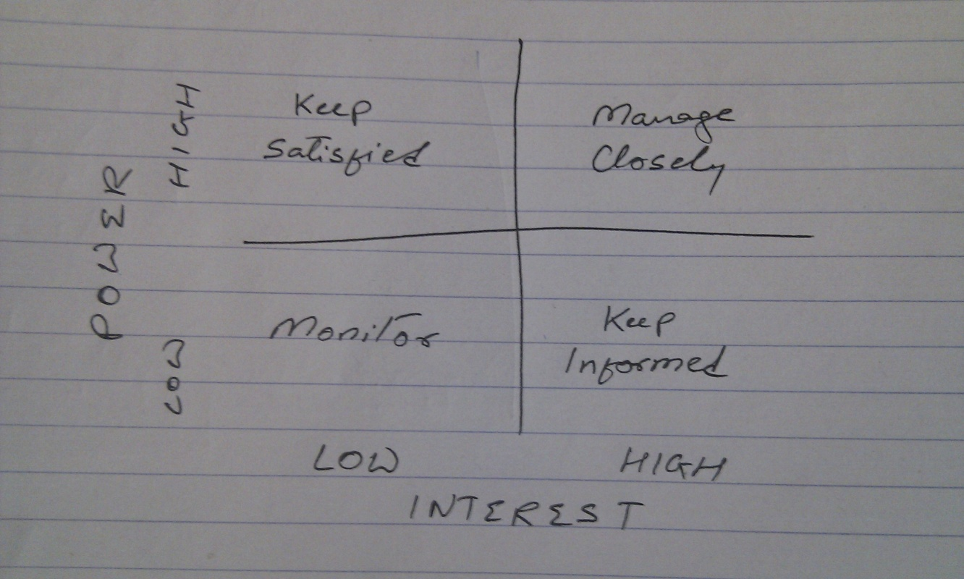
Can you find your Sponsor on this list?
- Delegated Sponsor
- Sideline Sponsor
- Automatic Sponsor
- Full-time Sponsor
- Executive Assistant Sponsor
- On the Fence Sponsor
- Collector Sponsor
- Accidental Sponsor
- Name Only Sponsor
- Busy Sponsor
- Missing In Action (MIA) Sponsor
- Project Sponsor in Disguise
- Indecisive Sponsor
- Seagull Sponsor
- Devil Sponsor
- Opposition Defiant Sponsor
- Counter Minded Sponsor
- Untrained Sponsor
- Saboteur Sponsor
- Buy Dinner Sponsor
Which category is your Sponsor?
Or if you are a Sponsor do you recognise being in one of the above categories?
Leave a Reply here

